**A Three-Population SEIR Model of COVID-19 Dynamics Informs Reopening of Stanford University Under Different Policy Scenarios** Ross Alexander*1, Tejas Athni*2, Ryan Crowley*3, Adonis Rubio*2

1 Department of Aeronautics & Astronautics, Stanford University, Stanford, CA, USA

2 Department of Biology, Stanford University, Stanford, CA, USA

3 Department of Biomedical Computation, Stanford University, Stanford, CA, USA

* Authors listed in alphabetical order; all contributed equally

## I. Introduction

The ongoing pandemic of COVID-19, a deadly coronavirus disease transmitted by the SARS-CoV-2 agent, has already radically reshaped our world. Amidst the direct effects of COVID-19 on morbidity and mortality, the outbreak has modified our day-to-day lives and social institutions, at times in incredibly significant and other times in relatively subtle ways. One particular area of disruption has been education: schools and universities have been positioned at a difficult crossroads — in charge of balancing delivering quality education to students with mitigating the public health risks of full on-campus activity. Mathematical and epidemiological models, such as the one constructed and analyzed in this research work, can play critical roles in informing policy decisions that will impact the trajectory of this outbreak and any future pandemics.

### 1.1 Objectives

Here, we aim to model disease transmission dynamics of COVID-19 for three subpopulations of interest - Stanford students, Stanford campus workers and faculty, and the surrounding Santa Clara County community - under different campus policy scenarios at Stanford University. Utilizing SEIR models stratified by these three distinct subpopulations and constructing an aggregate model that allows for pairwise interaction between these groups, we assess how different disease mitigation strategies, on-campus protocols, and behavioral patterns may impact Stanford’s disease trajectory. Our work aims to more robustly model inter-group contacts found on Stanford’s campus to better capture differential vulnerabilities and trends seen in the three subpopulations. Compared to previous literature, our group aims to design a model specifically geared towards the Stanford campus. Ultimately, our data-driven modeling can help inform policy planning that can reduce unnecessary disease risk that may be placed on Stanford students, workers, and members of the Santa Clara County community.

### 1.2 Justification

COVID-19 has created significant uncertainty in countries around the world regarding the feasibility and safety of reopening university campuses. While all universities are composed of similar groups of students, faculty & staff, and surrounding community members, universities have responded vastly differently to the challenge of reopening using a variety of disease mitigation strategies. Significant discussion has centered around how COVID-19 prevalence levels affect the feasibility of reopening [(Wrighton & Lawrence 2020)](https://paperpile.com/c/FPo3Ur/bAHk). Equally important, there exists a significant uncertainty related to risk to essential campus workers and risk to community members that accompanies a college reopening scenario during the COVID-19 pandemic [(Harper 2020)](https://paperpile.com/c/FPo3Ur/DCLT). For instance, there is evidence that the reopening of colleges has directly led to severe and even deadly cases of COVID-19 in communities that interact with college students [(Richmond *et al.* 2020)](https://paperpile.com/c/FPo3Ur/3z7C). Hence, in our research we hope to explore 1) the safe reopening of college campuses and 2) the potential impact of college reopenings on surrounding communities. The results of this work will be practically applicable as they can help inform university policy on winter quarter reopening, return-to-campus planning, and shaping of mitigation strategies to reduce case counts when undergraduate students eventually return to campus. Overall, we hope that our work will highlight classes of potential prevention measures that can lessen the disease burden that returning Stanford students may have on the surrounding community and essential campus workers.

### 1.3 Background

Previous studies have utilized a two-population model to understand transmission dynamics between university students and the surrounding community during different reopening scenarios [(Benneyan *et al.* 2020)](https://paperpile.com/c/FPo3Ur/wyEy). Other approaches have looked at possible disease mitigation strategies such as entry screenings [(Elbanna *et al.* 2020)](https://paperpile.com/c/FPo3Ur/0nsf) and phased reopenings [(Rennert *et al.* 2020)](https://paperpile.com/c/FPo3Ur/Ikoh). Taking inspiration from these varied approaches, we aim to develop our own multi-population model for Stanford to assess COVID-19 transmission dynamics. Further, we aim to create a three-population model in order to capture the inter-group contacts that occur on campus and to take into account the full set of individuals that are at increased risk due to the return of Stanford students. Additionally, our study will not only present a unique methodological approach not previously seen in the literature, but our study will also shine light on how Stanford can formulate its policy to prevent adverse outcomes from COVID-19 in its next phase of reopening and how it can help to ensure the safety of its students, staff, and the greater Santa Clara County community.

### 1.4 Contribution

Our work makes use of a unique three-population methodology. We bridge traditional SEIR modeling with a more realistic transmission model that we believe better captures the transmission dynamics typically observed in a university campus environment. Our model, though developed specifically for Stanford, serves as a generalizable framework that other universities, institutions, and campuses can deploy to simulate reopening while accounting for potential cross-community impacts.

### 1.5 Summary

In conclusion, the multi-population model we develop can be used to demonstrate the potential spread of COVID-19 among three subpopulations of the greater Stanford community. With this model, we can simulate various reopening scenarios to explore how different social policies and precautions can impact the severity and disease burden of the COVID-19 spread within and between subpopulations. We hope that our analysis helps to inform reopening decisions by taking into account the importance of interactions between different groups on the Stanford campus.

## 

## II. Methods

### 2.1 Epidemiology model

To model interaction and disease propagation among students, faculty/staff, and the surrounding community, we formulate a stratified epidemiological model by synthesizing three population-level compartmental epidemiology models and allowing for interaction between the three populations, as depicted in the following figure.

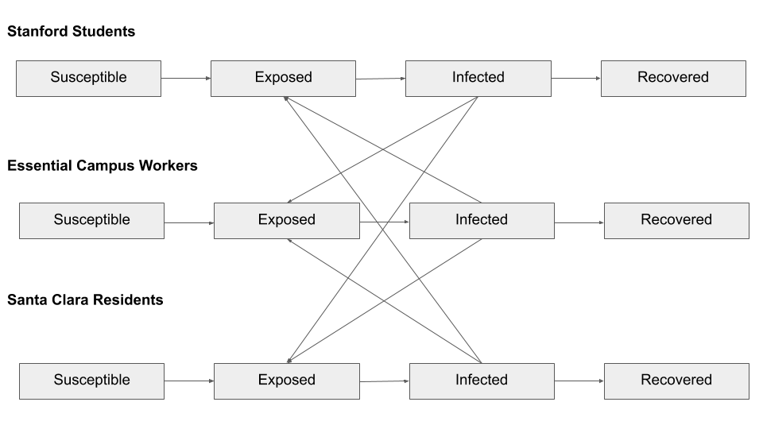

***Figure 1.*** Schematic depicting the three-population SEIR model with cross-population interactions.

For each population, we choose to model the population using a standard SEIR model, with the population divided into susceptible (S), exposed (E), infected (I), and recovered (R) compartments, where the compartment variable represents the number of individuals in that compartment. The population size is fixed to N = S + E + I + R and we neglect changes in the population size due to births and deaths. The evolution of the number of individuals in each compartment is governed by a series of coupled first-order nonlinear ordinary differential equations. To incorporate interaction between populations, we introduce additional contact rate terms for the transition of susceptible individuals to exposed individuals by infectious individuals in other populations.

In Figure 2, we show the differential equations governing the SEIR compartments for group *i* (*i* = 1, 2, 3), which corresponds to a particular population (students, campus staff, or community members, respectively). The parameters of this model are given in vectorized form in Figure 3.

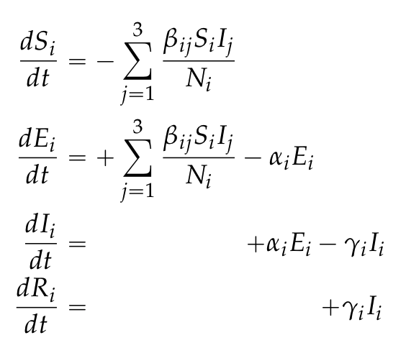

***Figure 2.*** Differential equations for each SEIR population (*i* = 1, 2, 3).

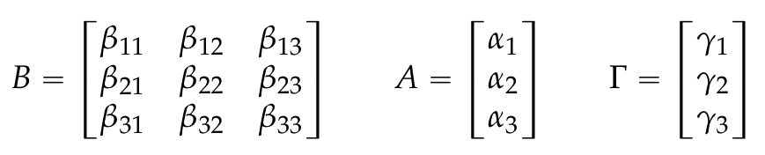

***Figure 3.*** Three-population SEIR model parameters: contact rate matrix (B), infectious rate vector (A), and recovery rate vector (Γ).

*B* is a symmetric matrix describing the pairwise contact rate between susceptible individuals from group *i* and infectious individuals in group *j*. While there are 12 total independent parameters listed (6 for B, 3 for α, and 3 for γ) we simplify the model to have equal α values and equal γ values for all communities. This reduces the model complexity to 8 independent parameters, while still remaining a flexible and interesting model. Code for this section that simulates the interactions between groups and creates the SEIR curves can be found in code_seir_simulator_new.ipynb

We utilize published literature to estimate model parameters such as intra-population contact rate, latent rate, and infectious rate. Since there is little prior information on ranges of values for inter-population contact rates, we selected reasonable values for the inter-population contact rates by qualitatively assessing the nature of inter-population contacts relative to each community’s intra-population contact rate. We supplement our estimation procedure using Bayesian methods to determine distributions over the basic reproduction number ℛ0, which is a directly related to the contact rate for a known infectious rate.

### 2.2 Mobility model and data acquisition

We use a network modeling approach to identify reasonable initial conditions (seeds) for our SEIR models [(Chang *et al.* 2020)](https://paperpile.com/c/FPo3Ur/iVYL). In particular, we utilize case data from the onset of the COVID-19 pandemic up through November 11th, 2020. For all groups, the SEIR initial values are calculated through the following formulas where *N* is the size of the specific group of individuals of interest (students, staff, etc.) and where *total testing population* refers to the total number of individuals within the population that we drew testing data from:

Utilizing the New York Times COVID-19 GitHub dataset, we extract the case data necessary to calculate I0 and R0. With data procured from Stanford on the number of students returning from every US state, we calculate (S0, E0, I0, R0) initial values for undergraduate year 1 and 2 students coming from each state. We also calculate (S0, E0, I0, R0) values for international students and students from US territories by utilizing global COVID-19 dynamics. The assumption of global dynamics is applied here since more granular data on the geographic source location of international students was not available to us. For undergraduate and graduate students who lived on campus in the autumn quarter, we calculate these subpopulations’ initial values using a set of conservative assumptions. Through data obtained from conversations with the Stanford administration, we ascertain that approximately 5,000 graduate students and 650 undergraduate students were residing on campus during the autumn quarter. We then assume that 50% of these individuals would remain on campus for winter break and would experience transmission dynamics localized to the Stanford bubble. Hence, we use the Stanford COVID reporting dashboard to calculate their (S0, E0, I0, R0) initial values. We approximate that the remaining 50% of individuals would leave campus for winter break, assuming that their dynamics would thus be consistent with the state of California’s aggregate COVID dynamics. Finally, we estimate the initial (S0, E0, I0, R0) for campus faculty and staff and the surrounding Santa Clara County community using the Santa Clara County case data. The resulting values are then used as inputs for the SEIR simulations in conjunction with Bayesian methods to create an estimate for the regional ℛ0.

Code for this section can be found in the jupyter notebook named

code_Seeding_SEIR_0_Network.ipynb.

### 2.3 Bayesian inference

We utilize a Bayesian inference model to determine the ℛ0 for community spread within Santa Clara County. We first obtained case data for COVID-19 in Santa Clara County using the New York Times COVID-19 GitHub dataset that tracks cases on the county level in the United States, and then we fit various parameters (𝛼, β, 𝛾, 𝜌, and N) to the case data. We attempted to assess the ℛ0 for the Santa Clara County community, using three fitting approaches: fitting data for a constant ℛ0, fitting data with a hyperbolic tangent function using Bayesian inference, and fitting data with a Gaussian random walk function using Bayesian inference. Ultimately, we use the ℛ0 value produced through the Gaussian random walk fit (ℛ0 ~ 1.65) due to its ability to closely fit the case data with its non-monotonic, stochastic, and non-closed functional form.

Probabilistic programming was performed using the pymc3 package in Python. Priors distributions for the parameters were first defined as follows: the observation error (σobs) assumed a Half-Cauchy distribution with beta equal to 1; the initial recovered population (R_begin) was set to 0; the initial exposed and infected populations (E_begin, I_begin) were specified with log-normal distributions with mean equal to the initial confirmed case numbers and standard deviation equal to 1; the initial susceptible population (S_begin) was the sum of the infective and exposed populations subtracted from the total population. Specifically, the random walk function was parameterized with the following: a mean value drawn from a normal distribution with a mean of 2.5 and a standard deviation of 2.5; tau was specified by an exponential function with input 1.0/2.5. The SEIR model prediction was then calculated using the aforementioned parameters, with a fixed 𝛼, 𝛾, and N, and the likelihood function defined. Posterior sampling was then performed using a bi-chain, bi-core Markov Chain Monte Carlo (MCMC) method utilizing 500 draws from each of the models after 500 initial tuning samples. 1000 samples were drawn from the posterior distribution in order to quantify the model uncertainty.

Code for this section can be found in the Jupyter notebook titled “code_infer_R0_Santa_Clara.ipynb.”

## 

## III. Results & Discussion

### 3.1 Initial conditions and model parameters

Before any policy scenarios were tested, it was first necessary to seed initial S0, E0, I0, and R0 values from a network-based mobility model that takes into account local COVID-19 transmission dynamics at each source location from which undergraduate students would be returning to campus. The resulting seed values from the mobility network are provided in Table 1.

|  |  |  |  |  |  |
| --- | --- | --- | --- | --- | --- |
| **Seed Type** | **S0** | **E0** | **I0** | **R0** | **Total** |
| Currently residing in a U.S. state | 2562.73 | 2.12 | 5.52 | 65.63 | *2636* |
| Currently residing *internationally* | 324.88 | 0.06 | 0.17 | 1.89 | *327* |
| Students currently on campus *leaving* for winter break & returning | 2754.59 | 1.23 | 3.21 | 65.97 | *2825* |
| Students currently on campus *staying* for winter break | 2794.44 | 1.93 | 5.02 | 23.60 | *2825* |
| *Total seeds* | *8436.64* | *5.35* | *13.92* | *157.09* | ***8613*** |

***Table 1.*** Numbers of S0, E0, I0, R0 seeds obtained from domestic, international, campus-leave, and campus-stay populations and associated source location disease dynamics followed by a network model.

In Figure 4, we can see the results from running Bayesian inference to assess the changing of the value of ℛ0  over time. The model was run on the past two weeks of COVID-19 case data from Santa Clara County. From the different fits, we can see that the fit for the Gaussian Random Walk has significantly lower error bars and more accurately represents the changes in case data over the past two weeks. Given the superior fit of the Gaussian Random Walk, we chose to utilize this approach for our initial value of ℛ0  to input into the model (ℛ0 ~ 1.65). Additionally, since we wanted our model to incorporate the most recent data, we chose to utilize the final value given by the Gaussian Random Walk approach as our ℛ0 value to input into the model.

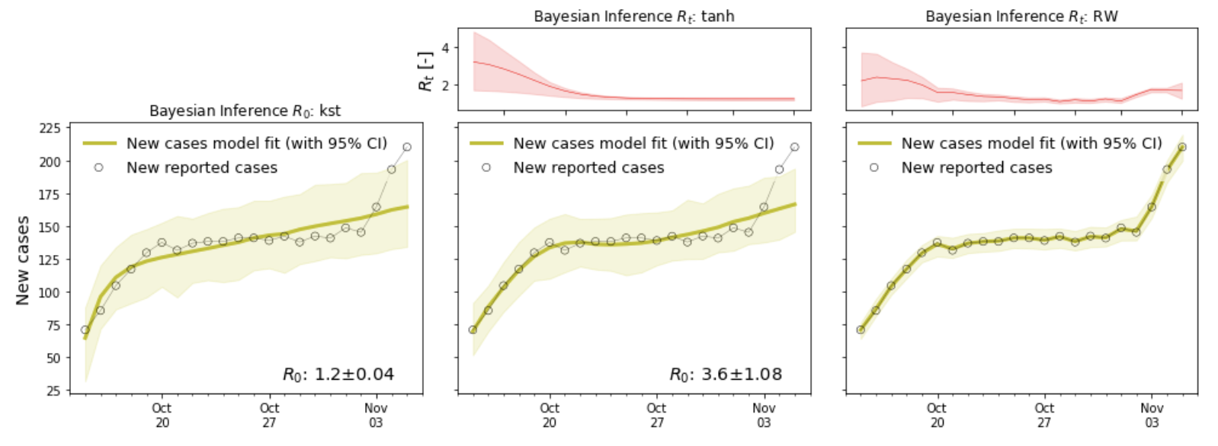

***Figure 4.*** Results from the Bayesian inference of ℛ0 from COVID-19 case data.

We assume a latent rate of ɑ = 0.4 and an infectious rate ɣ = 0.15. For our given infectious rate and ℛ0 = 1.65 from our Bayesian inference procedure, we get a baseline value of β = 0.2475. We use this value along the diagonal of our *B* matrix and modify the off-diagonal terms as follows to reflect notional differences in inter-population contact behaviors: βii = 0.2475; β12 = β21 = βii/10; β13 = β31 = βii/15; β23 = β32 = βii/15.

In Table 2, we outline eight distinct policy scenarios that may yield meaningful insights into linking administrative measures with COVID-19 outcomes. These scenarios represent a variety of possible changes to intra-population and inter-population interactions that could influence disease transmission dynamics. In each of these scenarios, we provide a brief interpretation of each policy and provide multiplicative factors for the contact matrix parameters relative to the baseline parameters. In the following subsection, we examine the scenarios in detail. We use the term ℛ0 loosely to represent the standard intra-population contact rate divided by the population infectious rate.

|  |  |  |
| --- | --- | --- |
| **Scenario Code** | **Policy Interpretation** | **Multipliers for Beta Terms**  **(β11, β12, β13, β22, β23, β33)** |
| A | Uninhibited scenario, with no substantial policy intervention regarding isolation or contact | 1.0, 1.0, 1.0, 1.0, 1.0, 1.0 |
| B | 50% reduced inter-group contact between students, faculty, and Santa Clara County community | 1.0, 0.5, 0.5, 1.0, 0.5, 1.0 |
| C | No inter-group contact between students, faculty, Santa Clara County community | 1.0, 0.0, 0.0, 1.0, 0.0, 1.0 |
| D | Student-only lower ℛ0 | 0.5, 1.0, 1.0, 1.0, 1.0, 1.0 |
| E | Student and faculty lower ℛ0, with no student-faculty contact | 0.5, 0.0, 1.0, 0.5, 1.0, 1.0 |
| F | Student and faculty lower ℛ0, with no student-community contact and limited faculty-community contact | 0.5, 1.0, 0.0, 0.5, 0.1, 1.0 |
| G | Student and faculty lower ℛ0, with no inter-group contact for students or faculty | 0.5, 0.0, 0.0, 0.5, 0.0, 1.0 |
| H | Globally-lower ℛ0 | 0.5, 1.0, 1.0, 0.5, 1.0, 0.5 |

***Table 2.*** Different policy reopening scenarios at Stanford.

### 3.2 Baseline scenario

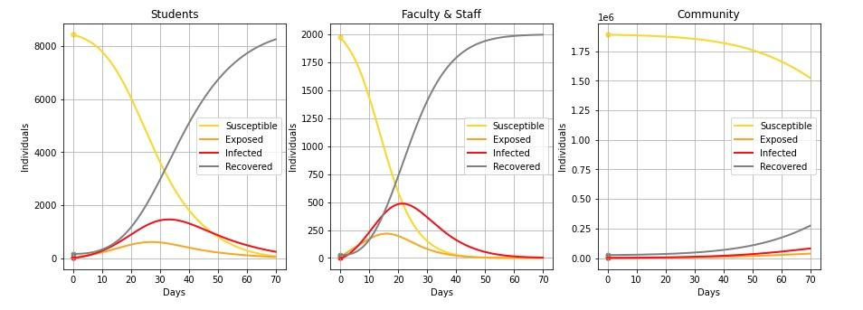

***Figure 5.*** *Scenario A:* Uninhibited scenario with no substantial policy intervention regarding isolation or contact.

In this baseline scenario with no policy interventions in place, the entirety of both the students and faculty/staff populations experience COVID-19 infection. Peak infectivity for the student population is roughly at 32 days post-seed, while for faculty the peak lies slightly earlier at 20 days. The peak is more pronounced in the faculty population. In contrast, the Santa Clara community experiences a steady, less-acute increase in infections and recovered subgroups as the 70-day observation period progresses, with a change in curvature occurring right around the 60-day mark. With no administrative measures in place, COVID-19 infection will be uncontrolled on the Stanford campus, signifying a need for substantive policy to be enacted in order to avoid an overloading of isolation dorms, hospital beds, and healthcare resources within the first month of school reopening.

#### 

### 3.3 Reducing inter-population contact

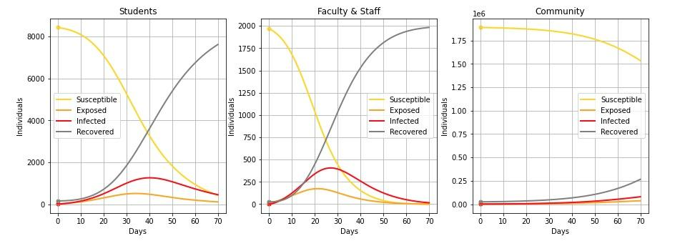

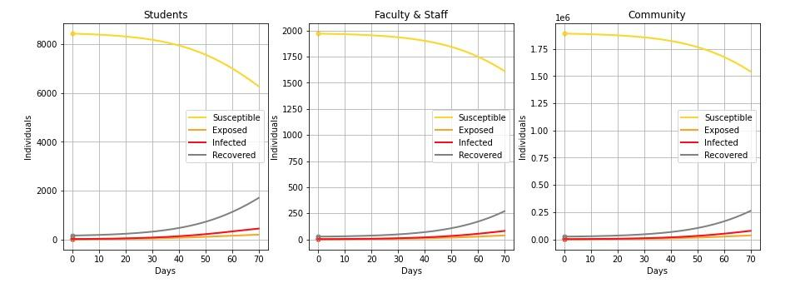

***Figure 6.*** *From top to bottom: Scenarios A, B, and C. Scenario A:* Uninhibited scenario with no substantial policy intervention regarding isolation or contact. Scenario B: 50% reduction in inter-population contact rates. Scenario C: 100% reduction in inter-population contact rates.

Much public health discourse has centered around the need for reduced inter-group contact. Social distancing, cancellation of mass gatherings, and remote work are staple non-pharmaceutical interventions that have been implemented across the country [(Kucharski *et al.* 2020)](https://paperpile.com/c/FPo3Ur/6Dt1). In Scenario B, we analyze the effect of a 50% reduced inter-population contact among students-to-faculty, faculty-to-community, and students-to-community. A multiplier of 0.5 for the inter-group contact rate (β) serves as an operationalized, real-world equivalency to the aforementioned non-pharmaceutical contact mitigation strategies. As compared to the baseline scenario, this modification results in a delayed peak infectivity for both the student and faculty/staff subgroups, with a roughly 7-day delay for both groups. However, the infection runs its course throughout the entirety of both subpopulations with all individuals recovered from the infection around day 70. In the Santa Clara County community, the curves qualitatively appear nearly identical to the baseline scenario. Thus, a reduced inter-group contact policy and non-pharmaceutical contact mitigation results in, at best, a one week delay in peak infectivity of students and staff in our model.

Scenario C models the situation where there is no inter-group contact between the three groups. The infectives and exposed lines tend to experience a pronounced decrease in slope and peak as compared to Scenarios A and B, and the susceptibles remain the majority group throughout the 70-day observation duration. Further, we can see that by limiting the contact between these three groups, the overall case number is significantly decreased compared to the baseline case of the first scenario where there is no limitation of the inter-group contacts. Thus, we can assess that entirely limiting inter-group contact is a much more efficacious approach than the Scenario B, where inter-group contact was only limited to 50% of normal contact. Reducing intergroup interactions can have a pronounced impact on case numbers when within-group interactions are not significantly lowered. Although this scenario is theoretical, and the complete limitation of intergroup contact is difficult to implement, it serves as a powerful pedagogical tool.

#### 

### 3.4 Reducing the basic reproduction number

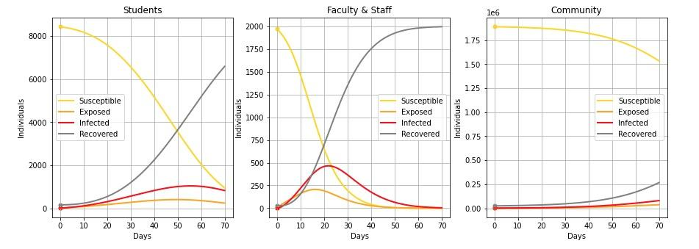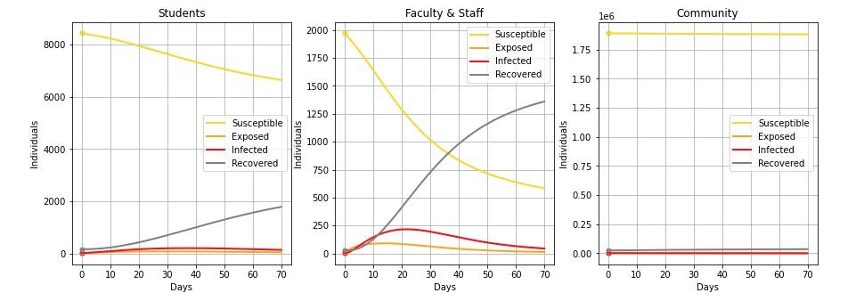

***Figure 7.*** *From top to bottom: Scenarios A, D, and H. Scenario A:* Uninhibited scenario with no substantial policy intervention regarding isolation or contact. *Scenario D*: Student-only 50% lower ℛ0. *Scenario H*: Globally 50% lower ℛ0.

Scenario D models the situation where the ℛ0 for students is 50% the baseline ℛ0  value, but there still exists interactions between students and other groups including the community and faculty and staff members. This scenario models the situation where interactions between students are significantly limited due to Stanford COVID-19 protocols, but students still engage with outside communities. In the graphs, we can see that even with the lowered student ℛ0, a significant number of students end up becoming infected. This indicates the importance of limiting interactions between students and other groups. Even if students are maintaining a relatively low contact rate on campus, any interaction with a community where COVID-19 is widespread places the individuals on campus in danger of becoming infected with COVID-19.

In Scenario H, we have a situation where the ℛ0 is reduced among all populations but intergroup contact is still allowed. This would represent a situation wherein both Stanford policy and county-wide policies significantly limit the spread of disease (possibly via mask-wearing and social distancing) but still allows for strong interactions between all three groups. In this scenario, we note that the infection within the Santa Clara community would be greatly reduced; there would still be infections among students and faculty/workers but peak infectivity is mitigated. This indicates that while lowering the ℛ0 will reduce the amount of infections, there will still be greater infections than, for example, Scenario G given that intergroup interactions are not restricted. Again, this would be a tricky policy scenario to implement because it is logistically difficult to only allow interactions between groups and not within groups. Nonetheless, this scenario reinforces our findings that intergroup contacts can contribute to infections among the student and faculty/worker populations.

### 3.5 Reducing the basic reproduction number and inter-population contact

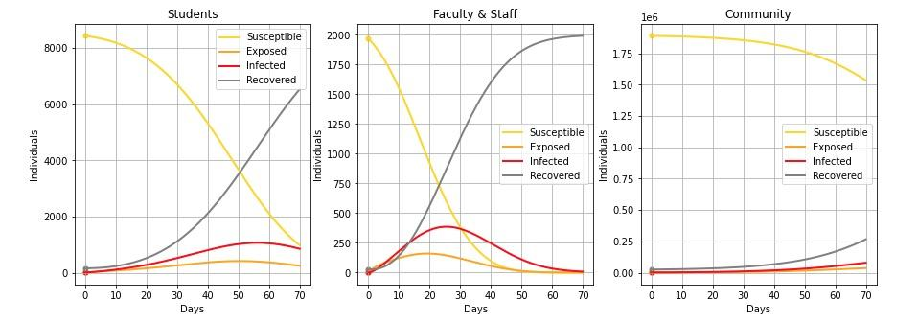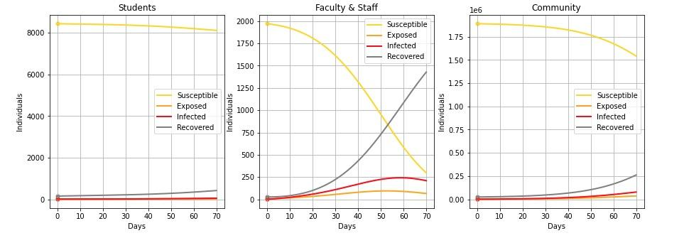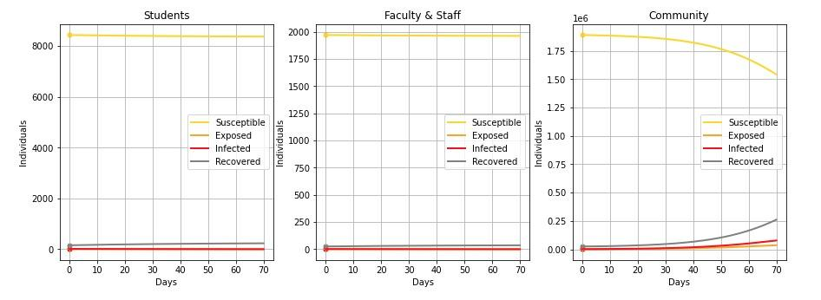

***Figure 9.*** *From top to bottom: Scenarios E, F, and G. Scenario E:* Student and faculty lower ℛ0, with no student-faculty contact. *Scenario F*: Student and faculty lower ℛ0, with no student-community contact and limited faculty-community contact. *Scenario G*: Student and faculty lower ℛ0, with no inter-group contact.

In Scenario E, we reduce the ℛ0 for the student population and faculty/campus workers was by 50% relative to the baseline case and do not allow for contact between students and faculty/campus workers. This scenario roughly corresponds to a remote learning setup with additional campus restrictions where students are isolated from faculty and on-campus workers at all times. In general, this scenario delays the peak infection time for students to approximately 56 days, while for faculty, it remains close to 25 days. We continue to observe that it is difficult to eliminate the virus entirely even under such seemingly restrictive conditions that we presume most people would feel would be sufficient to control COVID-19 spread.

Like Scenario E, Scenario F models a 50% reduction in the basic reproduction number. However, in Scenario F, we have no student-community contact and only 10% of the baseline faculty/staff-community contact. This policy is much closer to a “Stanford bubble”, where those affiliated with Stanford are allowed to interact with one another, but that they should not interact (or at least minimally interact) with the outside community. This policy leads to a significant improvement in the SEIR trajectories and highlights the fact that the student-community and faculty-community pathways are quite critical in maintaining a safe Stanford. While faculty are still relatively susceptible, their peak infections are shifted much further into the future and the infectious curve is much shallower, lessening any potential burden on isolation or medical resources. Through this example, we validate the idea of a “Stanford bubble” that could serve to keep individuals in the Stanford community much safer in light of few to no community policy interventions or poor community compliance to active community policies.

Next, we analyzed Scenario G, wherein the ℛ0 for the student population and faculty/campus workers was reduced by 50% compared to baseline, and with no inter-group contact. This scenario would model the scenario in which the entirety of campus would be locked down under a shelter-in-place order with students largely confined to their rooms, taking courses remotely, and unable to interact with the surrounding community. It also models the lack of contact between faculty/workers and the community. Here, we see that the infectivity among students and faculty and campus workers is drastically reduced indicating a success of the closed campus and lack of intergroup contact with the community. However, the infection within the Santa Clara community, while delayed, is not as drastically impacted most likely because the ℛ0 within the community is still unchanged. Therefore, this scenario demonstrates that students and faculty and campus workers are greatly protected when the ℛ0 is reduced and contact with the surrounding community, and between students and faculty/workers, is greatly limited. It is worth noting that this particular scenario is hard to obtain because it is realistically hard to separate and limit the contact between workers and the community as many of them may need to leave to and from campus and will interact with their families.

## 

## IV. Limitations & Future Work

Although our model accounts for a variety of nuances associated with intergroup dynamics, it is by no means perfect due to the inherent stochasticity of real-world human behavior. Many of the mathematical parameters and values utilized in our work are derived from Bayesian inference techniques, which accounts for some of the aforementioned variation. However, the task of modeling human action will always have an element of unknown. Future work should investigate how to account for varying levels of uncertainty around particular aspects of human and group behavior, in order to depict a more accurate interpretation of policies and their impact on infection dynamics among the three populations.

A limitation inherent to analyses of compartmental models such as these is the difficulty of predicting results far into the future. For instance, our model attempts to run a simulation over the course of 70 days. Given the immense uncertainty regarding public policy decisions and disease dynamics, coupled with the rapidly changing nature of COVID-19 developments, any such predictions are difficult to claim even broadly. As a result, our models are much more useful for making meaningful comparisons between different situations than they are in accurately predicting disease dynamics at the end of Stanford’s winter quarter.

Another important limitation of our model is that it assumes a constant ℛ0 and hence is unable to adjust for the possibility of a change in the true underlying contact rate over time. This limitation is especially important to consider for the Stanford students as well as Stanford staff as it is likely that restrictions on activities would increase significantly if cases were to rise at the levels indicated by the results of our model.

Additionally, our model does not accurately account for Stanford’s biweekly testing regimen. This testing regimen would likely lead to a decrease in the ℛ0 values observed for Stanford students and Stanford staff as infected individuals would be identified earlier and would hence be less likely to spread COVID-19.

## V. Conclusion

Our work employs a novel three-population model focused on university students, university faculty and campus workers, and the surrounding community. The results gained from our analysis are in accordance with much of the current literature surrounding safe reopenings of universities. Through our mathematically-rigorous analysis of eight different reopening policies and COVID-19 restrictions, we have examined the significant impact of inter-group interactions beyond the traditional scope of student-to-student interactions in isolation. Furthermore, our work provides a new framework to assess the impacts of COVID-19 while accounting for multiple stakeholders’ perspectives.

In particular, our work identifies the importance of COVID-19 prevalence and transmission dynamics within the surrounding community on the transmission dynamics of the populations on campus — an often under-recognized group in such analyses. Importantly, our study highlights the importance of emphasizing contact restrictions uniformly across faculty and campus workers, in addition to students, for a safe and open university during COVID-19.

## 

## VI. References

[Benneyan, J.C., Gehrke, C., Ilies, I. & Nehls, N. (2020). Potential Community and Campus Covid-19 Outcomes Under University and College Reopening Scenarios. *medRxiv*.](http://paperpile.com/b/FPo3Ur/wyEy)

[Chang, S.Y., Pierson, E., Koh, P.W., Gerardin, J., Redbird, B., Grusky, D., *et al.* (2020). Mobility network modeling explains higher SARS-CoV-2 infection rates among disadvantaged groups and informs reopening strategies. *Epidemiology*.](http://paperpile.com/b/FPo3Ur/iVYL)

[Elbanna, A., Wong, G.N., Weiner, Z.J., Wang, T., Zhang, H., Liu, Z., *et al.* (2020). Entry screening and multi-layer mitigation of COVID-19 cases for a safe university reopening. *Epidemiology*.](http://paperpile.com/b/FPo3Ur/0nsf)

[Harper, S.R. (2020). COVID-19 and the Racial Equity Implications of Reopening College and University Campuses. *Am. J. Educ.* , 000–000.](http://paperpile.com/b/FPo3Ur/DCLT)

[Kucharski, A.J., Klepac, P., Conlan, A.J.K., Kissler, S.M., Tang, M.L., Fry, H., *et al.* (2020). Effectiveness of isolation, testing, contact tracing, and physical distancing on reducing transmission of SARS-CoV-2 in different settings: a mathematical modelling study. *Lancet Infect. Dis.*, 20, 1151–1160.](http://paperpile.com/b/FPo3Ur/6Dt1)

[Rennert, L., Kalbaugh, C., McMahan, C., Shi, L. & Colenda, C.C. (2020). The urgent need for phased university reopenings to mitigate the spread of COVID-19 and conserve institutional resources: A modeling study. *Infectious Diseases (except HIV/AIDS)*.](http://paperpile.com/b/FPo3Ur/Ikoh)

[Richmond, C.S., Sabin, A.P., Jobe, D.A., Lovrich, S.D. & Kenny, P.A. (2020). SARS-CoV-2 sequencing reveals rapid transmission from college student clusters resulting in morbidity and deaths in vulnerable populations. *Public and Global Health*.](http://paperpile.com/b/FPo3Ur/3z7C)

[Wrighton, M.S. & Lawrence, S.J. (2020). Reopening Colleges and Universities During the COVID-19 Pandemic. *Ann. Intern. Med.*, 173, 664–665.](http://paperpile.com/b/FPo3Ur/bAHk)